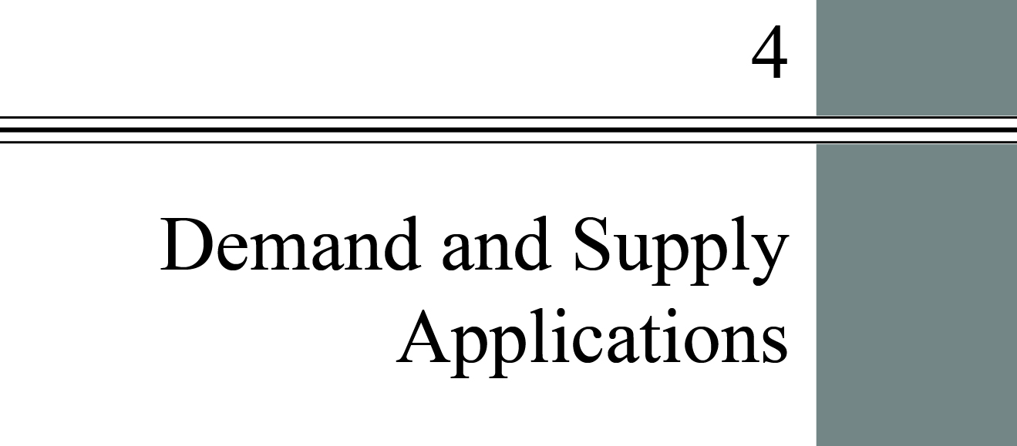

**chapter Outline**

**The Price System: Rationing and Allocating Resources**

Understand how price floors and price ceilings work in the market place

**Supply and Demand Analysis: Tariffs (Tax)**

Analyze the economic impact of an oil import tax

**Supply and Demand and Market Efficiency**

Explain how consumer and producer surplus are generated.

detailed chapter Outline

I. Introduction

This chapter continues studying supply, demand, and the price system. Markets and prices allow society to make *decentralized* decisions.

II. The Price System: Rationing and Allocating Resources

A. The price system performs two important and closely related functions.

1. It provides an automatic mechanism for distributing scarce goods and services. *Price rationing* is the process by which the market system allocates goods and services to consumers when quantity demanded exceeds quantity supplied. Price rationing eliminates shortages and surpluses in free markets.

2. It determines the allocation of resources among producers and the final mix of outputs.

**Unique *Economics in Practice***

For the 2008 fishing season, salmon fishing was banned off the coasts of northern California and southern Oregon. At the same, time bad weather in Alaska limited the salmon catch from that source. According to the Alaska Public Radio Network, prices for wild salmon ranged from $9.77 to $10.25 per pound. The prized Copper River salmon carried a hefty retail price of $45 to $50 per pound. Alaska Airlines had expected to ship 20,000 pounds of salmon. Their actual shipments were 7,500 pounds.

Question: Is there a shortage in this market? Explain your answer.

Answer: There is no shortage. The high price in this market simply reflects increased scarcity. However, the market is in equilibrium.

B. Price Rationing

1. When there is a shortage or surplus the price will adjust toward equilibrium.

2. There is always some price that will clear any market.

3. Fires during the summer of 2010 destroyed much of Russia’s wheat crop. The result was a decrease in supply. The equilibrium price rose from $160 per million metric tons to $247, while the equilibrium quantity fell from 61.7 million metric tons to 41.5 million.

4. There are items such as family heirlooms that the owner will not sell for any price. If true, that simply means the current owner is also the highest bidder.

|  |
| --- |
| **Unique *Economics in Practice***  Between 2008 and 2009, the quantity of lobsters caught in Maine increased by 8 percent. But the total value of the catch fell by $23 million, about 10 percent. (The “value” is, of course, total revenue to lobstermen.) The figures in the example imply prices for lobsters of $3.50 in 2008 and $2.93 in 2009. So total revenue in 2008 must have been $245 million. The table below summarizes the results.    Question: More lobsters were sold in 2009. Why didn’t revenue increase?  Answer: The increased quantity was more than offset by a lower price. Total revenue is price times quantity, constrained by the demand curve. In this case, an 8 percent increase in quantity caused a 16.3 percent decrease in price. The net impact on revenue was a decrease of 9.6 percent. |

C. Constraints on the Market and Alternative Rationing Mechanisms

1. Governments and private firms sometimes decide to ration a particular product using some nonprice mechanism. The rationale given for this is usually “fairness” which includes:

a. price-gouging is “bad”;

b. income is distributed “unfairly”; and

c. some items are “necessities” and everyone should be able to buy them at a “reasonable” price.

2. There are two key results.

a. Attempts to use non-price rationing are usually more difficult and more costly than expected.

b. Very often such attempts distribute costs and benefits among households in unintended ways (the law of unintended consequences again).

3. Oil, Gasoline, and OPEC

a. The Organization of the Petroleum Exporting Countries (OPEC) has 12 countries as members. Together, OPEC supplies about   
40 percent of the world’s oil. That is a large enough market share to have an impact on the world oil price as long as the OPEC members cooperate and limit their output to production quotas. But we are long past the days when OPEC could actually control global oil prices.

b. In 1973 and 1974 the OPEC oil embargo reduced the quantity of gasoline available in the United States. If the market system had been allowed to operate gasoline prices would have risen dramatically. A good estimate was an equilibrium price of $1.50 per gallon (remember, this was the mid-1970s). Congress imposed a price ceiling of $0.57 per gallon on gasoline. The equilibrium price and price ceiling are dramatically illustrated in Figure 4.3.

c. A *price ceiling* is a maximum price that sellers may charge for a good, usually set by government.

d. The “fairness” rationale was that the price ceiling would keep gasoline from being so expensive that the poor could not afford it.

e. This did not resolve the problem of excess demand. Instead some other mechanism was used to ration. The three most common methods are queuing, favored customers, and ration coupons.

i. In 1974 the non-price rationing mechanism for gasoline was queuing. *Queuing* means waiting in line as a means of distributing goods and services: a nonprice rationing mechanism.

ii. A second non-price rationing device was favored customers. *Favored customers* are those who receive special treatment from dealers during situations of excess demand. One way of becoming a favored customer is to pay a bribe to the seller.

iii. A ration coupon system requires two means of payment for a product. One payment is money. The other (and limiting) payment is ration coupons. *Ration coupons* are tickets or coupons that entitle individuals to purchase a certain amount of a given product per month.

f. When a price ceiling is imposed a black market usually develops. A *black market* is a market in which illegal trading takes place at market-determined prices.

4. Rationing Mechanisms for Concerts and Sports Tickets

a. Tickets to see the Broadway hit “Hamilton” were sold on the black market for as much as $1,000. When the Chicago Cubs finally made it to the World Series, the black market price of a ticket was as high as $3,500. In both cases, the face value of the ticket was far lower.

b. Some favored individuals—friends of the artists, friends of the promoters, local politicians, sponsors—will get tickets without queuing. They may even pay a price of zero for their tickets.

c. Once the market mechanism begins to work the concept of *opportunity cost* take control. The true cost of a ticket to any event is the opportunity cost of actually using the ticket and sitting in the seat. If people are willing to pay $500 for your ticket that is the true cost of attending the concert.

**Unique *Economics in Practice***

The seven game 2010 NBA championship series paired two legendary franchises: the Boston Celtics and the Los Angeles Lakers. A ticket for a courtside seat at the Staples Center in Los Angeles reportedly sold for $19,000.

Question: How would fans have reacted if either team charged $19,000 per ticket?

Answer: Howls of outrage about how unfair the team was to its loyal fans.

D. Prices and the Allocation of Resources

1. The market determines more than just the distribution of final outputs. It also determines what gets produced and how resources are allocated among competing uses.

2. Increases in demand (outward shifts in the demand curve) cause higher prices, which raise profits, attract capital and increase wages. Higher wages attract labor. Thus, markets determine the allocation of resources and the ultimate combinations of products produced.

3. An ongoing trend is the increase in meals eaten away from home. This trend began in the 1980s. Restaurant prices rose, increasing profits. The profits attracted entrants. Wages for culinary workers also rose. Enrollments in culinary schools rose. New cooking schools opened. Supply, demand and prices in both output and input markets influence the allocation of resources and the quantities of final products.

E. Price Floor

1. A *price floor* is a minimum price below which exchange is not permitted.

2. The result will be excess supply (a surplus).

3. The minimum wage is probably the most famous example of a price floor. A *minimum wage* is a price floor set for the price of labor.

III. Supply and Demand Analysis: Tariffs (Tax)

A. Should the United States impose a tariff (tax) on imported oil? By using the tools of supply and demand we can see the preliminary results.

B. Imposing this tariff (tax) would increase domestic oil production and reduce domestic demand. U.S. oil imports would decrease. This would have the benefits of reducing air pollution, U.S. dependency on foreign oil, and the trade deficit. (The issues of “dependency” and the “trade deficit” are normative economics.)

C. Will oil exporting countries retaliate with tariffs (taxes) of their own?

 ***TOPIC FOR CLASS DISCUSSION*** 

President Trump has famously claimed that trade wars are “easy to win.” Ask the class to discuss what “winning” would look like. Are we winning when U.S. consumers pay higher prices for imported goods? Do we win when less efficient production is protected from foreign competition?

IV. Supply and Demand and Market Efficiency

A. Price rationing is the key to understanding how markets allocate scarce goods and services.

1. Supply and demand can also be used to measure market efficiency.

2. Economists use consumer surplus and producer surplus to measure changes in market efficiency.

B. Consumer Surplus

1. A demand curve reveals the maximum prices consumers would be willing to pay for various quantities of a product.

2. In most markets, however, the product actually is sold at only one price.

3. Consumers who would have been willing to pay more for the product are getting a good deal.

4. *Consumer surplus* is the difference between the maximum amount a person is willing to pay for a good and its current market price.

5. Since we usually deal with market demand curves, we measure total consumer surplus as the total amount consumers would have been willing to spend. Total consumer surplus is the area between the demand curve and the market price.

C. Producer Surplus

1. A supply curve reveals the minimum prices at which sellers would be willing to sell various quantities of the product.

2. In most markets, however, the product actually is sold at only one price.

3. Producers who would have been willing to sell the product for less are earning producer surplus.

4. *Producer surplus* is the difference between the current market price and the cost of production for the firm.

5. Since we usually deal with market supply curves, we measure total producer surplus as the area between the supply curve and the market price.

D. Competitive Markets Maximize the Sum of Producer and Consumer Surplus

1. *Total surplus* is the sum of producer and consumer surplus.

2. In equilibrium a competitive market maximizes total surplus.

3. If either the price or quantity is restricted there will be a deadweight loss. The *deadweight loss* is the total loss of producer and consumer surplus from underproduction or overproduction.

E. Potential Causes of Deadweight Loss from Under- and Overproduction

1. Monopoly power.

2. Taxes and subsidies.

3. External costs or benefits.

4. Price ceilings and floors.

****Extended Application

Application 1: The War On Drugs

The U.S. government’s “war on drugs” mainly focuses on restricting supply. This drives up prices and reduces quantity demanded. However, demand for many drugs is price inelastic. That means quantity demanded does not drop as much as the price rises. The net effect is higher total revenue to drug producers. Alternative policies might focus instead on reducing demand (education, rehabilitation); and legalization.

In the following graph Pm and Qm are the free market price and quantity while Pw and Qw are the “war on drugs” price and quantity. The supply curve has been shifted inward because the “war on drugs” emphasizes reducing supply. The steep demand curve, of course, is caused by inelastic demand.

Price

Quantity

Qm

Pm

Qw

Pw

D

Sm

Sw

Application 2: Tariffs (Taxes) on Chinese Tires

In September 2009, President Obama imposed a 35 percent tariff (tax) on imports of tires made in China. The immediate effect of this was to increase the price of those tires in the United States. But the domestic tire market is more complicated than you might think. There are three “tiers” of tires sold here: flagship (Tier 1), secondary (Tier 2), and mass-market (Tier 3). Premium Tier 1 tires are mainly made by Bridgestone, Goodyear, and Michelin. Tier 2 tires are made by B.F. Goodrich, Firestone, and Uniroyal. Tier 3 is economy, mass-market tires. While the large multinationals have some presence in this market (e.g., Bridgestone’s “Dayton”; Goodyear’s “Remington”; Michelin’s “Medalist”) most Tier 3 tires are produced by smaller “private brand” U.S. companies (e.g., American Omni, Del-Nat, Dunlap & Kyle). Since margins are very low in Tier 3, major U.S. producers have largely abandoned producing tires for this segment. There is, in fact, little substitution among consumers between Tier 1 and Tier 3.

Prof. Tom Prusa of Rutgers University has analyzed the U.S. tire market, focusing on the impact of these tariffs (taxes).[1] His conclusions are staggering, but not particularly surprising to economists. The 35 percent tariff (tax) was predicted to:

* Reduce Chinese tires to the United States by 2/3 (30 million fewer tires).
* Increase shipments from other countries by about 8 million tires. After 12 months or so the extent of trade diversion will increase and imports from countries other than China will increase.
* Increase domestic shipments by about 2 million tires, far fewer than the 30 million tires we will no longer import from China;
* Result in a net decrease in tires consumed of about 7 percent (from about 276 million to about 256 million);
* “Save” about 1,000 U.S. tire jobs but cost about 20,000 downstream jobs in related tire industries (e.g., installers, service, sellers).
* The lower sales (resulting from the higher prices caused by the tariff (tax)) puts a bunch of jobs at risk in light of the past 18 months weak economy.
* Consumer cost per job saved is over $330,000.

Finally, consider some of the other consequences. Tier 3 tires are mainly purchased by low-income households. The two ways to make tires longer are to drive less or use the same tires for more miles. The increased risk from drivers with bald tires is not included in Prof. Prusa’s analysis.

1. Prusa, Tom, “Estimated Economic Effects of the Proposed Import Tariff (Tax) on Passenger Vehicle and Light Truck Tires from China.” Unpublished working paper, Rutgers University, July 26, 2009. Personal communication with the author.